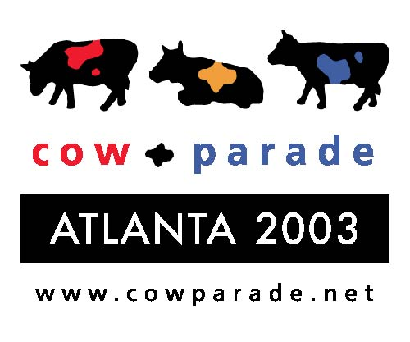

Information on obtaining photos of the cows and logos of CowParade and sponsors

Photo CD’s are available with high resolution pictures of cows from past events and all sponsors logos.

To obtain high resolution photos of the cows from past CowParade events and sponsor logos via the internet go to:
www. hayslettsorrel.com/incoming
Username: Distinctive
Password: Events

CowParade will take photos of all Atlanta cows for the official commemorative book in June. The media is welcome to take photos of the cows while they are professionally lit.
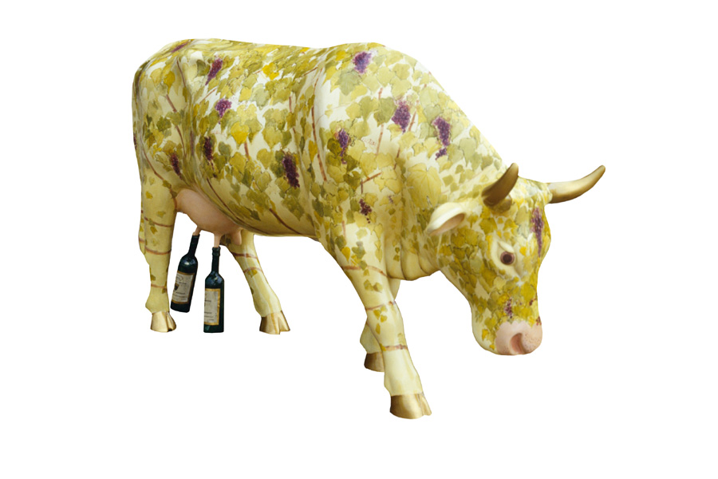
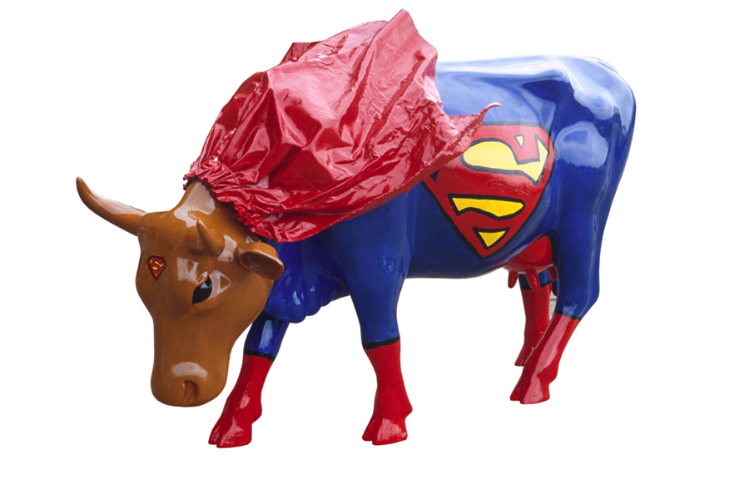
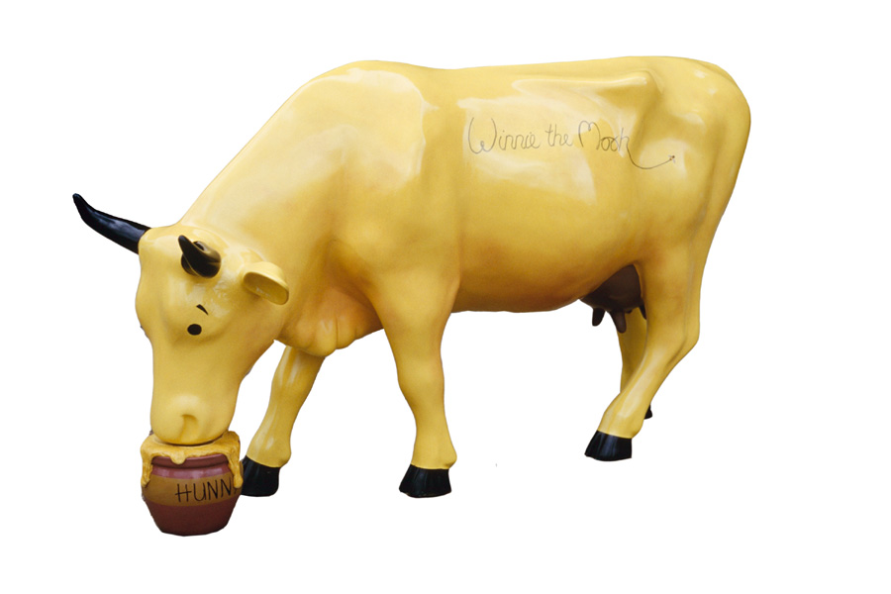

Cow-bernet Sauvignon Cow

Artist: Charlotte Ardizzone

Sponsor: Golden Vineyards

Supercow

Artist: Katie Harper

Sponsor: Interior Business Moves

City Cow
Artist: Pamela Howard
Sponsor: Lovells

For More Information about CowParade Atlanta or to schedule a photo shoot, visit www.cowparadeatlanta.com or contact:
Sue Rodman, Hayslett Sorrel, 770-522-8855, ext. 217 or mobile 404-784-5650.

